Supplementary Figures S1-S5
ConsistPix: A Collaborative Multi-level Fusion Framework for Few-Shot Cross-Modality Medical Image Translation

Figure S1. Quantitative comparison of MRI-to-MRI translation performance across multiple tasks and datasets.
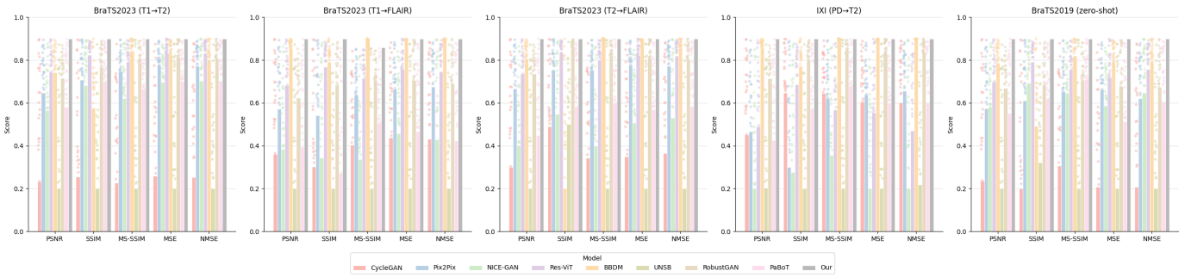

Figure S2. Multi-metric quantitative heatmap comparison of MRI-to-CT and CBCT-to-CT translation on the SynthRAD 2025 dataset.
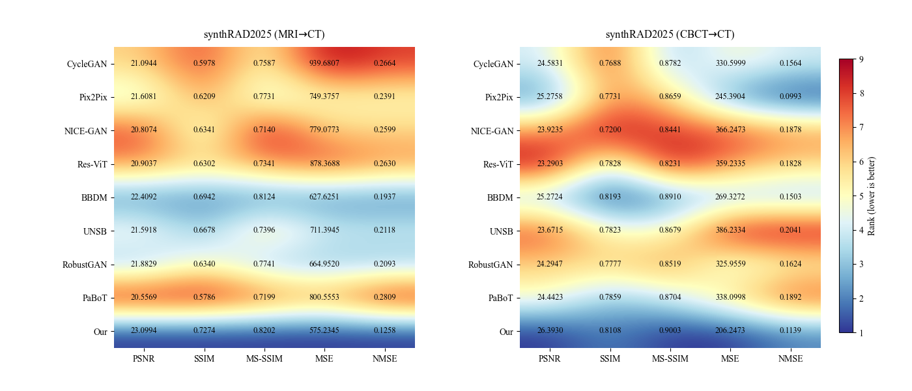

Figure S3. Error map visualization highlighting structural differences in T1-to-T2 translation.
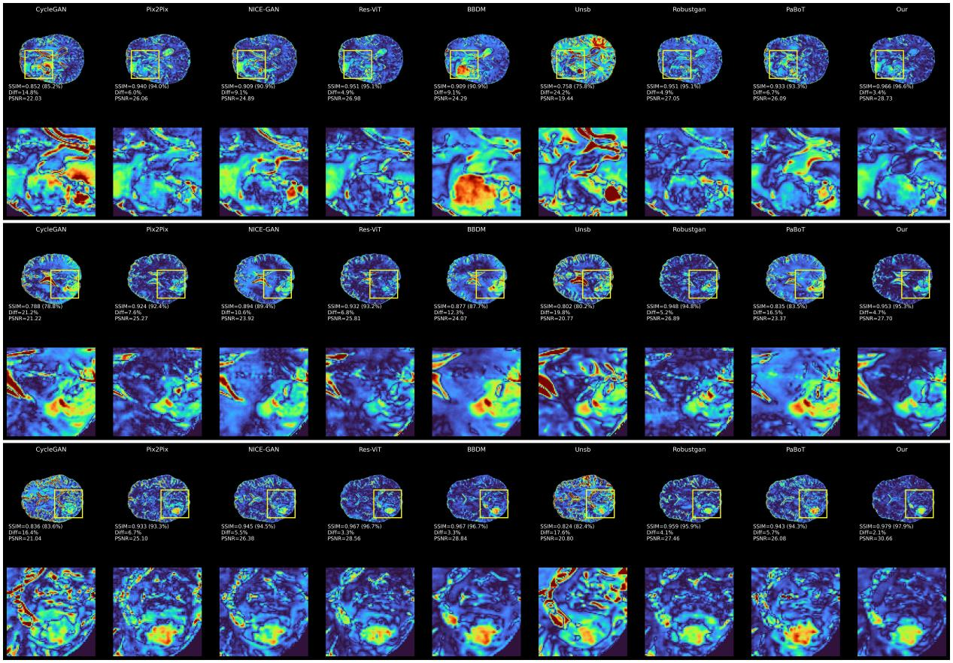
Figure S4. Error map visualization highlighting structural differences in PD-to-T2 translation.
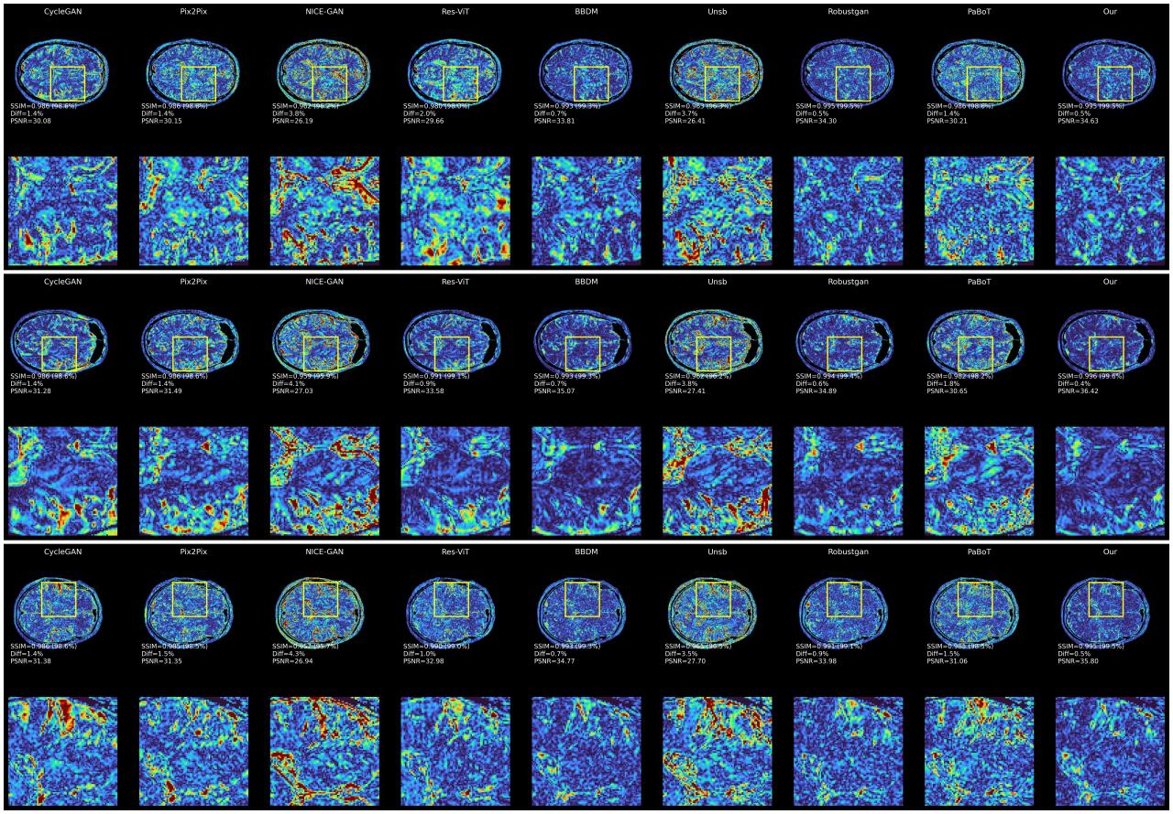

Figure S5. Error map visualization highlighting structural differences in CBCT-to-CT translation.
